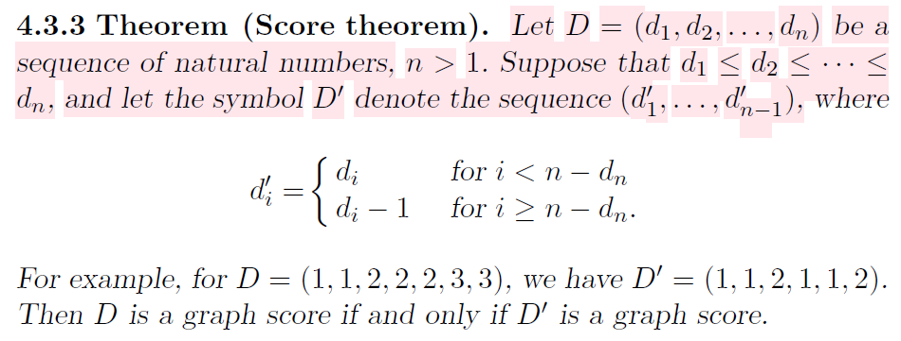

Note: Havel-Hakimi theorem is also known as Score Theorem, and Score = Degree sequence.

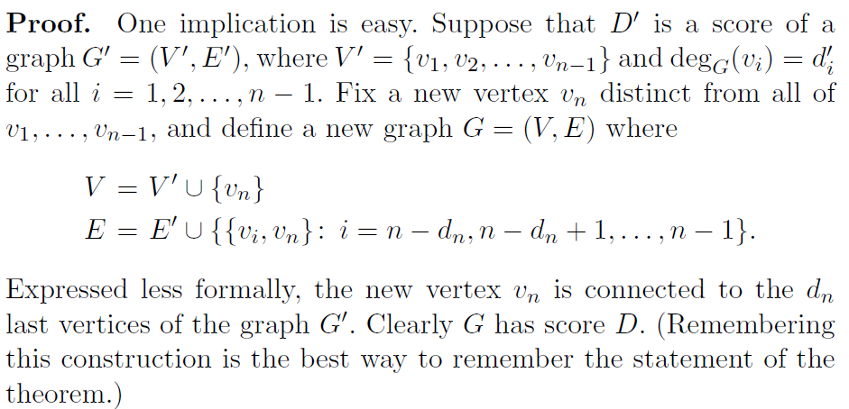

The other way implication is unclear to me, (P-145 in intro to DM book)